Villas by the Sea
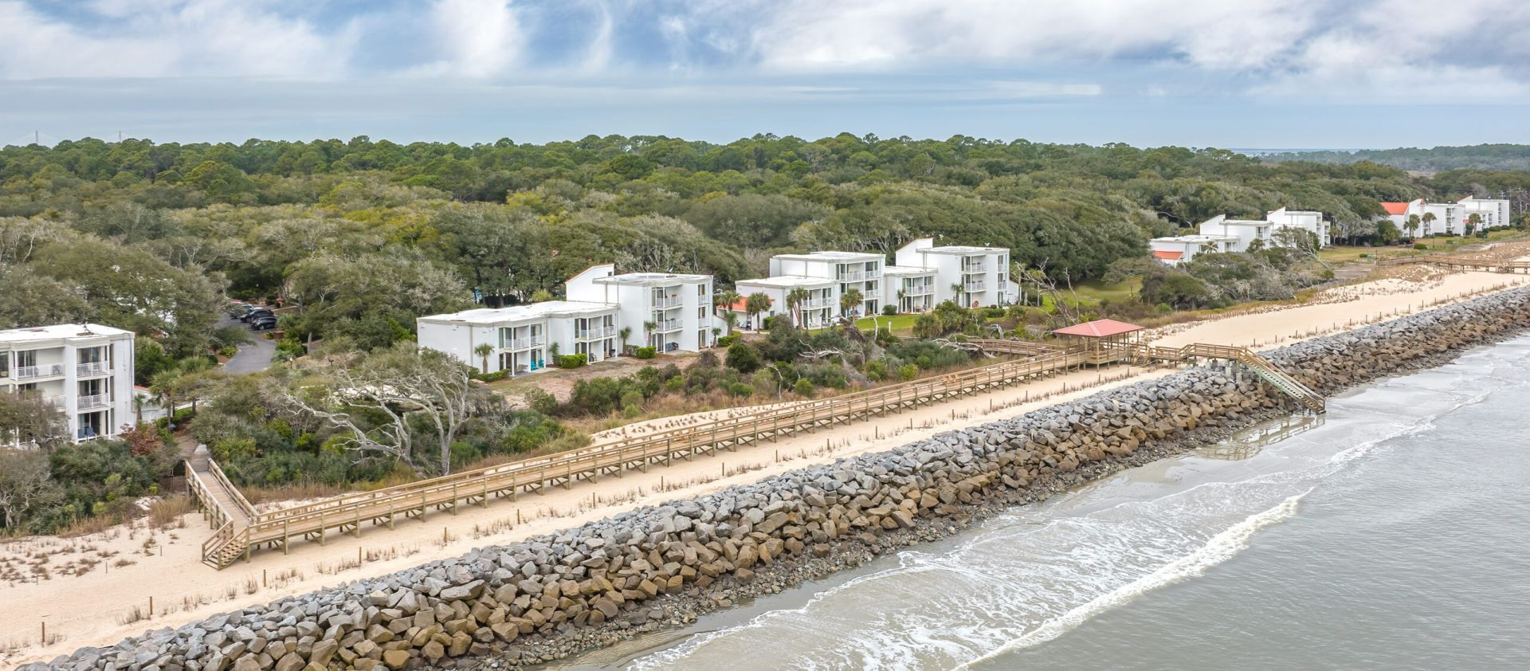
Location: 1175 Beachview Dr N, Jekyll Island, GA 31527
Phone: 912-635-2521 or 800-841-6262
https://www.villasbythesearesort.com/
Choose from one-, two-, or three-bedroom condominium villas with completely furnished kitchens, separate living and dining areas, private balconies or patios and individual climate control across the hotel. Each villa is thoughtfully and attractively furnished and shows the pride of individual hotel room ownership. All units are only a few steps from the beach and pool. In addition to the comforts of home, this vacation resort provides a wealth of hospitality and service, including optional daily maid service, 3 laundromats, bicycle rentals, and planned activities for varied interests. Free Wi-Fi allows you to research local attractions and keep up with loved ones back home.
Savor low country coastal cuisine in the Driftwood Bistro. Menu specialties include meat loaf, stuffed flounder, herb-crusted pork tenderloin, and fried, grilled and blackened Wild Georgia shrimp. Driftwood Bistro offers a great selection of vegetables, signature sandwiches and salads, with dishes served in either petite or regular portions. Special drink and bottle prices are available. Open Monday through Saturday 5 pm – 9 pm. Closed on Sunday. Also, the lounge is open from 4:30-5:30 Monday – Thursday for happy hour.) •
A variety of snack options as well as apparel and souvenirs are available 24//7 in the Villas Shoppe, adjacent to the Main Lobby
Resort Accommodation Reservations •
Room Rates:
- Mini Villa/Studio Villa $119
- One Bedroom $149
- Two Bedroom $229
- Three Bedroom $259
- 7% Sales Tax, 5% Hotel Occupancy Tax, & 5% Resort Fee are additional to room rate
- 2-night minimum required for group rates
- The special group rate is in effect with reservation code is #509901.

You may view room configurations on line, however you must call and mention that code when making your reservation. • Hotel reservations can be made any time up until March 7, 2022 or until the group block is sold out, whichever comes first. •
- Group Name: Georgia Nature Photographers Association
- Complementary on-site parking
- There are a very few pet-friendly units available
- Check In is at 4:00pm and Hotel
- Check out is no later than 11:00am
Condominium villas with completely furnished kitchens, separate living and dining areas, private balconies or patios and individual climate control across the hotel. • Each villa is thoughtfully and attractively furnished and shows the pride of individual hotel room ownership. All units are only a few steps from the beach and pool. • Villas at Villas by the Sea are perfect for an extended stay and much more comfortable than a hotel. • Accessible rooms are also available. Our comfortable 480 sq. ft. ADA compliant accessible accommodations feature a petite refrigerator, microwave, coffee pot and toaster. These rooms also come equipped with easy access roll-in showers. You will find comfort in the extra space these deluxe rooms offer at a hotel room price.
NOTE: Registering at the hotel does not include your EXPO registration. you must register separately for both the Resort and the EXPO.
If you have any questions not addressed here or have special needs, please call the hotel directly to make your reservations at 912-635-2521 or 800-841-6262. Be sure to use the group name: Georgia Nature Photographers Association AND Reservation Code #509901.

